Hi Jamie!
Below is the draft information for our March Marketing Newsletter. I wanted to try and get started on this draft, as it will be my first time doing the newsletter :) I am still solidifying some information in one or two articles, but I thought we could get the ball rolling and come back to small copy edits later. Can we please put a rush on this and request a proof for 3/1, tomorrow? Let me know if you need anything else from me!!

*Can we please use the design template here:
https://app.hy.ly/landing/1557350102320149712/edit
Header photo: Q1.2017 More Than Just an Apt- Rest your Paws2

Header Text: More Than An Apartment
Header text #2: A Place to Rest Your Paws

Article #1
Photo: New Year, Be You

Header Text: Quarter 1 Marketing Campaign
Body text: We strive to feel our best and be healthy in mind, body and spirit. As a reminder, we’re now rolling out our marketing campaigns quarterly, to give you more time to plan fun and creative events and memories for your community. Check out our Q1 Marketing Campaign below for more on what is to come this March. Let’s continue to fill 2017 with experiences and memories that will last a lifetime. From the time our future residents first inquire to when they sign their renewal, we want to strive to make coming home special, by cultivating a community. Make sure to take a look at the campaign below so we can accomplish this together.

CTA Text: Download The Campaign
CTA Link: Q1 2017 Seasonal Marketing Campaign.pdf (attached)

Article #2:
Photo: stars

Header Text: Stephanie Williams’ Ratings Challenge
Body Text:
As we dive deeper into part two of our Reputation contest series, it’s important to remember to: continue delivering extraordinary service to our residents and reply to all of their reviews, positive or negative. Our response matters and provides a window into our service recovery process--it is just as important as the service we provide. Please ensure that our residents know that we’re listening and that we care!

It’s just about that time. The top property management company will be determined after all data through March 31st is collected. We need your teams to keep pushing for more great reviews and to keep thanking our residents for any and all feedback.
CTA: Respond to Your Reviews Now
CTA link: https://www.reputation.com/
Article #3:
Photo: Like

Header Text: Facebook Pages Tip
Body text: Our social media specialist recommends the site teams download the “Pages” app on their iPads to easily post to Facebook. This will eliminate the confusion between posting on your personal Facebook account versus your property account.

CTA: Download the Pages App Now
CTA Link: https://play.google.com/store/apps/details?id=com.facebook.pages.app&hl=en

Article #4
Photo: TIPS

Header Text: Add New Users – Lead2Lease
Body text: Our digital marketing team wants to remind you to continue putting helpdesk tickets in for the Digital Marketing Queue to add new users rather than contacting RealPage directly.

CTA: Put in a Helpdesk Ticket
CTA Link: https://helpdesk.bozzuto.com/

Article #4

Photo: Calendar


Header Text: Resident Calendar
Body Text: This month we want to focus on engagement with our residents. Check out the link below for a resident calendar, to help your team stay organized when planning events. Discuss your plan for the upcoming month and use this template to pre-populate the calendar according to what is happening locally in your community and at your property. This tool will be a helpful way for your residents to see what you are planning, especially for properties that don’t have BuildingLink. We know you will enjoy the icons in the index, to add even more creativity and customization to intrigue your residents.

CTA: Outreach Calendar Template
CTA Link: BMC 2017 resident calendar template-landscape
Second CTA Link: BMC 2017 resident calendar template-portrait

Article #5

Photo: Bozzuto-Big-Game-Match-Up-FINAL
Header Text:

Body: Keri Walker’s Boston teams and Jo Gavigan’s Flats at Perimeter Place faced off on social media in a Superbowl LI showdown. Both sides did a fabulous job showing their team spirit while providing their residents with extraordinary experiences. Some teams threw Super Bowl viewing parties, some threw pre-game parties and others decked out the lobby and dressed the hospitality bars with treats and snacks for those residents heading out on the town to watch the big game.

CTA: View Boston’s Game Time Posts: https://www.instagram.com/explore/tags/bozzutoboston/
View Atlanta’s Game Time Posts: https://www.facebook.com/FlatsAtPerimeterPlace/

Property Spotlight
Article #1

Photo: Dalian_Int_Model_Kitchen4_2016
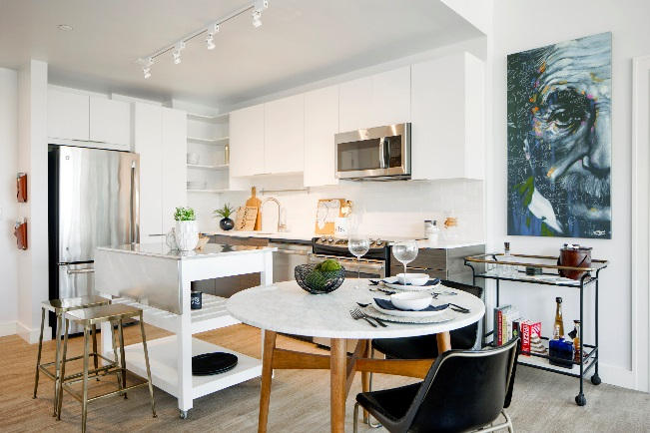

Header Text: Dalian on the Park

Body Text: Dalian on the Park, a brand new lease up in Philadelphia’s Art Museum District, is excited to announce their GoPro video featuring Adam Hendricks, Property Manager. This stylish new residential building in Philadelphia offers an exclusive opportunity to live amongst works by Degas, Van Gogh and Rodin. Surrounded by some of the world’s greatest cultural treasures, the Dalian is uniquely nestled between the Rodin Museum and the Philadelphia Museum of Art, designed with floor to ceiling windows and an infinity pool overlooking the city. Looking out onto Fairmount Park, the Dalian offers an opportunity to infuse everyday strolls with a glimpse of iconic sculptures like The Thinker and LOVE. For nature enthusiasts, the Dalian provides direct access to breathtaking outdoor spaces, flower gardens, picturesque Kelly Drive and the ever-evolving Schuylkill River Trail. A scenic tour along tree-lined Benjamin Franklin Parkway brings residents past lively fountains, through historic Logan Square and into Center City all in under 10 minutes.

CTA Text: Click Here to See Dalian on the Park Virtually
CTA Link: http://www.dalianonthepark.com/video-gallery/

Article #2:
Header image: CourtsofDevon_Ext_Amenities_Swim_Sep2013 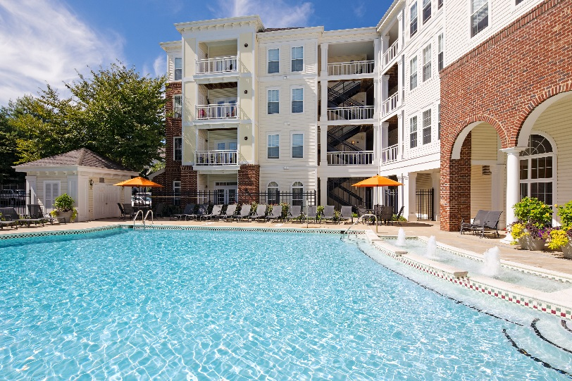
Header Title: The Courts of Devon Rated 7th Top Property
Body Text:
The Courts of Devon was awarded ORA’s 7th top property in the nation for online reputation/reviews. The Courts of Devon is also a Bozzuto owned community and one of our original properties. The best things in life have a way of coming back in style. From your Courts of Devon apartment home, you're never more than a few steps away from instant gratification. You can stay fit, day or night, or stay connected with free Wi-Fi. You can join your neighbors for a special event or enjoy some "me time" with a good book in front of a warm fire. Sip coffee in the lounge or chow down at the grill. Whatever you're into, we're out to make sure you have it.

CTA: Click Here to View The Courts of Devon’s Website
CTA Link: http://www.courtsofdevon.com/

Article #3:
Header Image: Flat 8300_Ext_Amenities_Courtyard_Sept2016
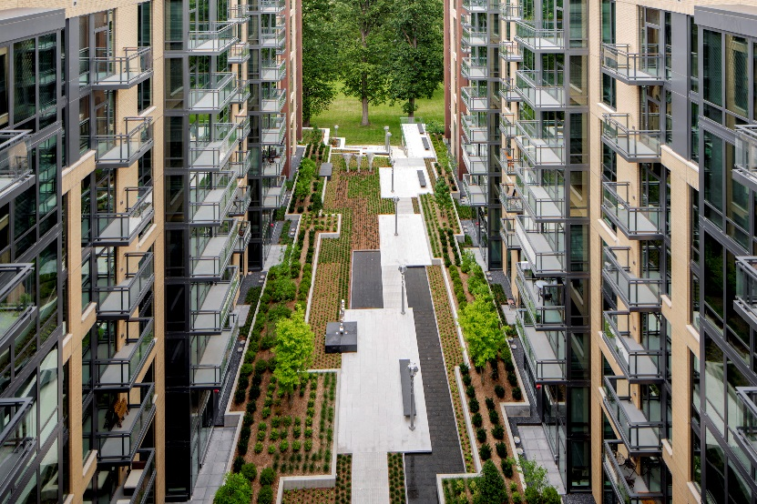

Header Title: Winning at the Wintergreens
Body Text: We’re excited to announce Flats 8300 has been honored by the U.S. Green Building Council (USGBC) at the Wintergreen Awards for Excellence in Green Building. The Wintergreens celebrate, promote and recognize excellence in high performance, healthy design and building, environmental stewardship and community impact.

Flats 8300, a nine-story multifamily residential project in Bethesda, MD, ranked impressively high across all of the nominations, especially in site design. The jury of sustainability experts were especially critical this year, according to Sabrina Bachman the director of community for USGBC Maryland, “It was tough to impress the jury on site design this year, so this was very high praise.” Congratulations to Flats 8300 and our sustainability team!

CTA: Click here to explore Flats 8300
CTA Link: http://www.flats8300.com/

Article #3:
Header Image: Winthrop_Int_Amenities_FitnessCenter_FXWellBranded4
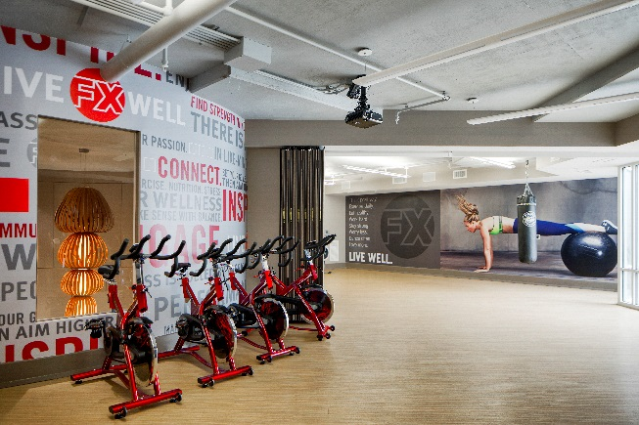

Header Title: Luxury Awaits in the heart of Towson

Body Text: Winthrop is excited to announce the rebrand of their fitness center with FX Well. FX Well includes a personal trainer for all residents and fitness performance training to help residents achieve their desired outcomes and goals. Winthrop offers modern upscale apartment homes and amenities you won't find anywhere else. From numerous community lounges to a game room, you're sure to feel the pride of Baltimore in the comfort of Towson. Relax and unwind poolside while soaking up the sun, then head over to Studio W, our acoustically engineered music studio fully equipped for garage band play, open-mic nights and solo practice.
CTA: Click here to explore The Winthrop
CTA Link: http://www.flats8300.com/

